Order Value Distribution Analysis
Objective
To evaluate the distribution of order values by calculating the mean and median order value. This helps assess whether customer spending is evenly distributed or skewed by a smaller number of high value purchases and provides insight into what a “typical” order looks like.
Approach
Order-level revenue was calculated by aggregating item-level data to derive a total value per delivered order (including product price and freight).
Two key metrics were then computed:
- Average Order Value (AOV): calculated as the mean of all order values.
- Median Order Value: calculated by ranking orders by value and identifying the middle observation(s) using window functions.
To visualise the distribution, order values were grouped into R$50 bins using SQL (via a FLOOR-based binning approach) and the resulting binned dataset was loaded into Power BI to create a histogram. For readability, the chart focuses on orders with values up to R$1,000, which represent the vast majority of transactions.
Key Findings
- Average order value: R$159.83
- Median order value: R$105.28

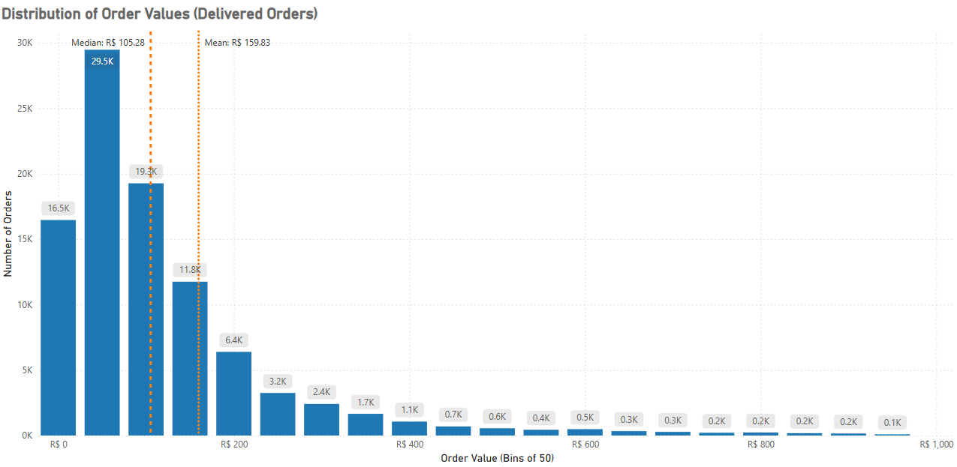
The histogram shows a clear right-skewed distribution, with most orders concentrated below R$200 and a long tail of higher-value purchases. The average is notably higher than the median, confirming that a small number of high-value orders disproportionately increase the overall average.

Business Implications and Recommendations

- The median order value (R$105.28) provides a more accurate representation of “typical” customer spend than the mean and should therefore be the primary metric used when designing pricing structures, bundles, and promotional thresholds.
- The gap between the mean and median highlights the disproportionate impact of high-value customers. This supports the use of targeted retention strategies for this segment, such as personalised offers, loyalty incentives, and tailored recommendations.
- Average Order Value should still be monitored as a commercial performance indicator but interpreted cautiously and always alongside the median to avoid overestimating typical customer behaviour.
- Pricing and promotional strategies should be aligned with the observed distribution, for example by setting free-shipping thresholds, bundle pricing, or minimum spend offers closer to the median rather than the mean.
- Ongoing monitoring of the order value distribution is recommended to assess whether strategic initiatives are successfully shifting more customers toward higher order value brackets over time.

